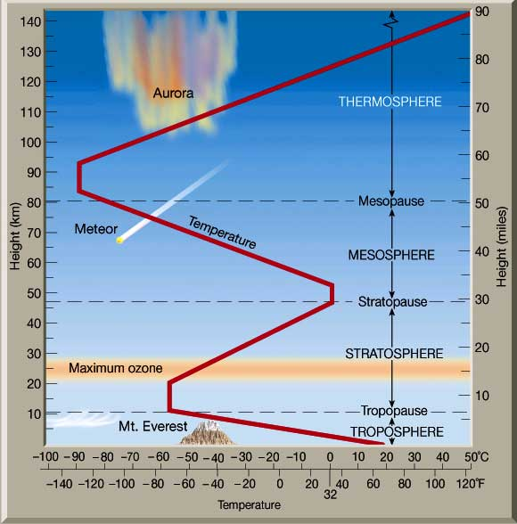
Layers of the Atmosphere Worksheet
- If you were to go halfway up the stratosphere, what temperature would it be?

- If you went 35 MILES into the air, what layer would you be in?

- If you went 35 KILOMETERS into the air, what layer would you be in?

- How are the Stratosphere and Thermosphere similar?

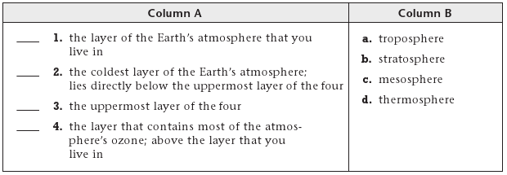
- Complete the following matching
- List the five layers of atmosphere we have talked about, and one thing that defines it or makes it different/distinguishable from the rest.
- ___________________ --
- ___________________ --
- ___________________ --
- ___________________ --
- ___________________ --
- What are the two main gases we find in the lower layer of the atmosphere?

- Which of the gases listed above is found at higher altitudes?

- Fill each layer with dots representing how dense the layer is with particles of air.
More dots = more dense
- Draw the examples given below in the diagram to show where each of them would be located

- Mount Everest (8k m):
- Meteors:
- Weather balloon (47.6 km):
- A flock of geese:
- Spacecraft orbiting (243 km):
- Jet airplane:
- Ozone Layer:
- Altostratus clouds (1.8 km):

